21BDS0340

Abhinav Dinesh Srivatsa

Computer networks Lab

Assignment – II

**Question 1**

Requirements:

* Cisco Packet Tracer
* PC
* Smartphone
* Laptop
* Wireless Router
* Wiring

Topology:

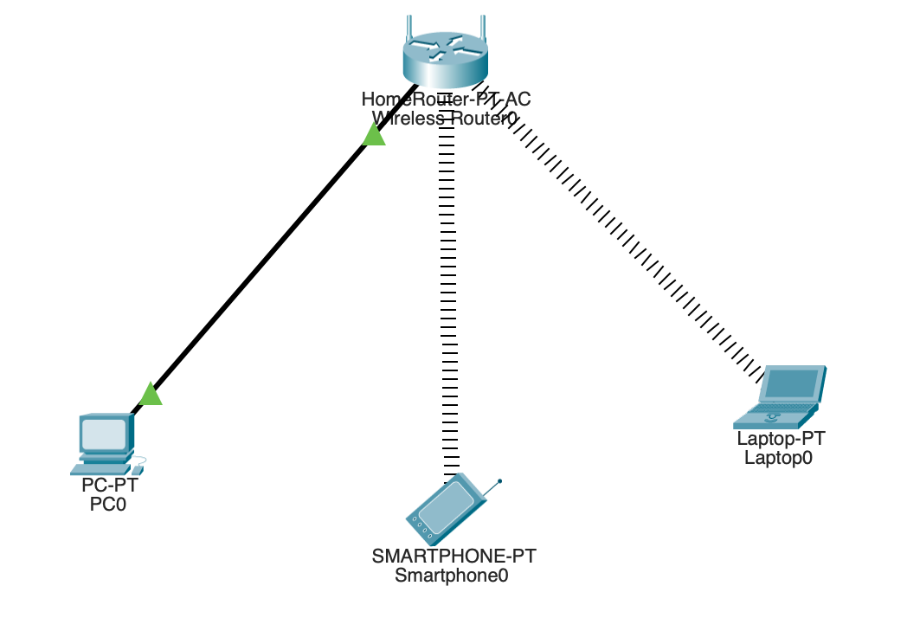

The smartphone and laptops are connected wirelessly and will accept a dynamically assigned port (DHCP). The PC is a static IP address connected to the router with a wire.

Output:

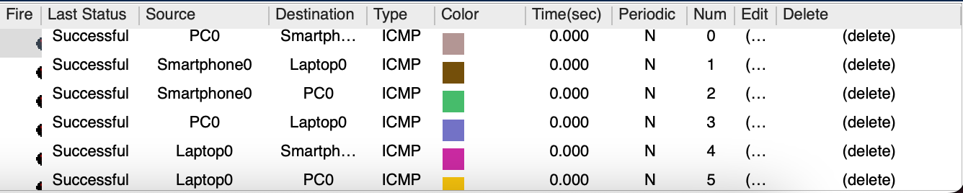

From this screenshot, all the connections between the laptop, PC and smartphone are successful. Therefore, the wanted connection is functioning properly.

**Question 2**

Requirements:

* Cisco Packet Tracer
* PC
* Switch
* Wiring

Topology:

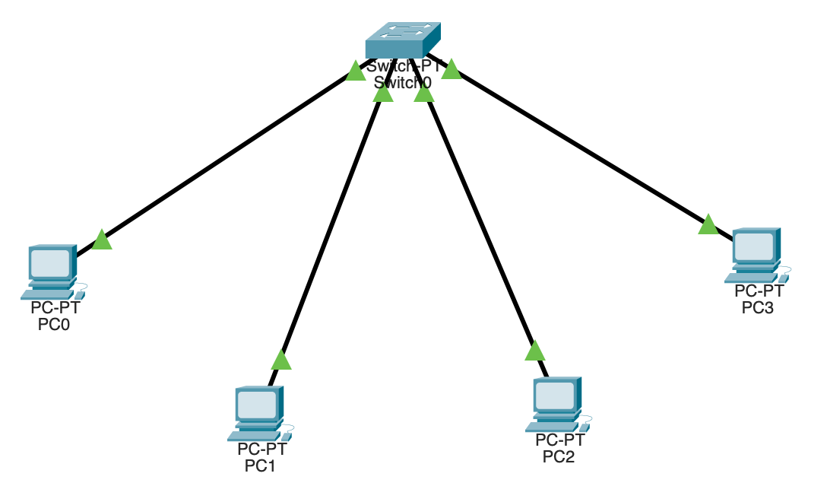

There are 4 PCs with IP address 192.168.0.1 – 192.168.0.4. These PCs are connected to each other with the bus topology implemented by a switch.

Output:

